# Project Guide Prof. (Lecturer in WPD)



**MAHARASHTRA STATE BOARD OF TECHNICAL EDUCATION**

**Certificate**

This is to certify that Master /Ms. Akshay Sontakke, Devendra meshram, Altamash sheikh, Heena burde, Yeshodeep shahare and Ritu choudhari of **2st** Semester of Diploma in computer engineering Of Institute, **Government Polytechnic, Gondia** (Code :- 1242) has completed the Micro **Project** satisfactorily in the Subject -  **(WPD)** for the Academic Year 2021- 2022 as prescribed in the curriculum.

**Place**: Gondia. N.

Date: 23/05/2022

|  |  |  |  |
| --- | --- | --- | --- |
| **Student name** | **Roll No.** | **Enrollment No.** | **Signature.** |
| Altamash sheikh | 49 | 2112420284 |  |
| Ritu chaiudhari | 50 | 2112420285 |  |
| Devendra meshram | 51 | 2112420286 |  |
| Yeshodeep shahare | 52 | 2112420287 |  |
| Heenan burde | 53 |  |  |
| Akshay Sontakke | 54 | 2112420288 |  |

**Subject Teacher** Seal of  **Head of the Department**

Institution

# GOVTERNMENT POLYTECHNIC GONDIA



# -SUBMISSION-

We Akshay Sontakke, Devendra meshram, Altamash sheikh, Heena burde, Yeshodeep shahare and Ritu choudhari **(respectively)**, as a student of **1st Year** of the Programme

**Computer Engineering** humbly submit that I have completed from time to time the Practical/Micro-Project work as described in this report by my own skills and study between the period from **30 April 2022** to **23 May 2022** as per instructions/guidance of Prof. Bhagyashri Meshram Mam

And that following students were associated with me for this work, however, quantum of my contribution has been approved by the Lecturer.

And that I have not copied the report on its any appreciable part from any other literature

in contravention of the academic ethics.

Date :

**Evaluation Sheet for the Micro Project**

**Academic Year: Name of the Faculty:**

**2021-2022 Bhagyashri Meshram Mam**

**Subject - WPD Course code: 22014 Semester: 2st**

**INDEX**

|  |  |  |
| --- | --- | --- |
| **Sr.No.** | **Topics** | **Page No.** |
| **1** | Rationale | 4 |
| **2** | Aim | 4 |
| **3** | Course outcomes addressed | 4 |
| **4** | Literature review | 4 |
| **5** | Actual Methodology Followed | 5 |
| **6** | Actual Resources used | 6 |
| **7** | Outputs of the Micro-project | 6,7,8,9,10 |
| **8** | Skill developed | 11,12 |
| **9** | Application of this Microproject. | 13 |
| **10** | Area of future improvement | 14 |

**PART B – Micro-Project Report**

**1.0 Rationale**

We have performed this micro-project for CREATE WEBSITE ON PHOTOGRAPHY WITH SOME PHOTOS AND CLIPS

* We have used MS word and Notepad for preparing websites.
* We also have a Google chrome to collect information about project.

**2.0 Aim of the Micro-project**

CREATE WEBSITE ON PHOTOGRAPHY WITH SOME PHOTOS AND CLIPS

## 3.0 Course Outcomes Addressed

1. We knows about various photography and it’s types
2. We are successfully able to understand how to create document & website
3. We knows about Computer and it’s functions.
4. We knows about Computer’s peripherals and their uses.

## 4.0 Literature Review

To perform this micro-project and to prepare report on CREATE WEBSITE ON PHOTOGRAPHY WITH SOME PHOTOS AND CLIPS

We used green manual to create micro project and used internet to create website. After that first we started internet connection then we used chrome browser to know how to make website.  After that, we used NOTEPAD to write html code, from <DOCTYPE html> to </html>, whatever html code is written inside it, which is used to make the website better and adjust it, and the attributes and tags used in it in NOTEPAD.

1. Notepad as Digital Diary
2. To Learn Basic Tasks of Computer
3. View and Edit Text Files
4. Creating Webpages
5. To Write Scripts

Tag and attribute are two concepts related to HTML. The main difference between tag and attribute is that a tag is a way of representing an HTML element in the program, while an attribute is a way of describing the characteristics of an HTML element.

The website links to be used in the html code and website are given next.

1. Website links : <https://www.w3schools.com/html/html_editors.asp>
2. <https://www.google.com/search?q=define+tag+and+attribute&clie>
3. <https://www.tutorialpandit.com/5-basic-uses-of-notepad/>
4. <https://www.w3schools.com/html/html_computercode_elements.as>
5. <https://www.w3schools.com/html/html_basic.asp>

html code and books to be used in website Books : WEB PAGE DESIGNING WITH HTML (22014) We used html code and tag attributes to create the website using WPD manual.

After creating the website, we first hosted the domain and then to upload it to the website.

First of all we used Profreehost <https://profreehost.com/> then registered in it, after that we gave domain name to the website, after that we followed further steps.

After that we used wp-admin text for <https://profreehost.com/> <http://fitnessgym.unaux.com/wp-admin/> After that we used wordpress <http://sv1.scriptinstall.rocks> :2082/ cpsess5653754309 /frontend/x3/softaculous/index.live.php?act=software&soft=26&tab=overview To accommodate the website used.

After that we used the following steps to host the website

COMPUTER SYSTEM: We have used DELL INSPIRON, 8th generation WITH INBUILT WINDOWS 10 Operating system of 3.20 GHz INTEL Pentium Core processor with i7technology computer (PC). Dell Inspire desktops and all-in-one PCs are designed with innovative technology and the latest features.

* OFFICE SOFTWARE PACKAGES: MS WORD. We have used MS word 2019 for creating our report to show how we have developed the application .Brief information about the software is as below Microsoft Office (or simply Office) is a family of server software, and services developed by Microsoft. It was first announced by Bill Gates on August 1, 1988, in Las Vegas. The first Our Vision: To create technically competent and socially responsible technicians for Industries and society. Our Mission: M1: To impart knowledge to cater the need of industries and society. M2: To develop technical and environment friendly competencies to solve real life problem. M3: To inculcate the spirit of team work, ethical values and leadership qualities. Version of Office contained Microsoft Word, Microsoft Excel, and Microsoft PowerPoint. Over the years, Office applications have grown substantially closer with Shared features such As a common spell checker, data integration, etc. The office is produced in several versions targeted towards different end-users and computing Environments. The original, and most widely used version, is the desktop version, available for PCs running the Windows, Linux, and Mac OS operating systems. Office Online is a version of the software that runs within a web browser, while Microsoft also maintains Office apps for Android and iOS.

## 5.0 Actual Methodology Followed

* In our team there are six members that is Akshay Sontakke, Devendra meshram, Altamash sheikh, Heena burde, Yeshodeep shahare and Ritu choudhari
* We distributed our work to create mico-project. 1st and 2nd person are collected the data and information from various website and software. 3rd and 4th person created report and proposal about the presentation and last person created hard copy of micro-project.
* First we understand the topic that is “CREATE WEBSITE ON PHOTOGRAPHY WITH SOME PHOTOS AND CLIPS . Then we decided to meet all members of micro-project group for discussion as well as we created whatSapp group to discuss both ways are online & offline. According to the format of micro-project, we collected data and information from various software and websites such as “Google, Blogger, YouTube, and

Wikipedia”, next we distribute the work to collect the information from various websites and software websites and software, then created website.

* In micro-project we take three main steps. First creating presentation means, collecting information, second create report with format and third, create proposal. According to the presentation of micro-project we created report and proposal. In college in our free time when lectures were off we discussed our micro-project. In this way we have created our micro-project.

**6.0 Actual Resources used (Mention the actual resources used).**

|  |  |  |  |  |
| --- | --- | --- | --- | --- |
| Sr. No. | Name of  Resource/material | Specification | Quantity | Remarks |
| 1 | Websites | [www.gpgondia.com](http://www.gpgondia.com/)  [www.msbte.com](http://www.msbte.com/)  [www.csdeptgpg.com](http://www.csdeptgpg.com/)  [www.computerscience.com](http://www.computerscience.com/) | 04 | - |
| 2 | Inbult software | Notepad, Google chrome browser. | 02 | - |

## 7.0 Outputs of the Micro-project

With the proper camera and vision, photography can make your life much better. Below are just a few of the many benefits of developing a love of photography.

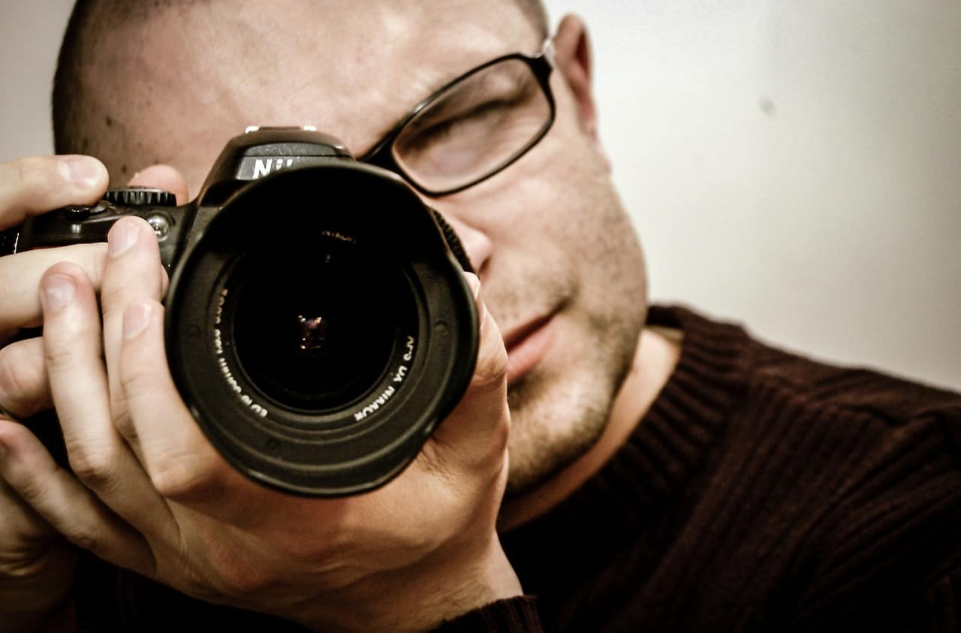

## 1. PHOTOGRAPHY AFFORDS IMMORTALITY

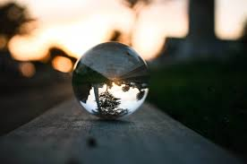Don’t believe it? Look at all the old photographs your mom or grandmother had around. I personally have a picture in my china cabinet of a newly married couple in 1911, and I have no idea who it is. (No, Cousin Ann, I don’t care to know.) I mean, it has their names on the back, but I’m not quite sure just where in the family tree they belong. I just think it’s cool. They looked so stiff and formal back then! It sure is different than how we take such natural pictures today. I personally will be immortalized laughing or smiling in many pictures.

## 2. PHOTOGRAPHY DOCUMENTS YOUR JOURNEY THROUGH LIFE

From your childhood pictures to your child’s pictures to your grandchild’s pictures. From first smiles to first steps to first dates, life can be documented and preserved. Photography captures personal communication that would otherwise be lost forever.

Many times I’ve noticed something in a photograph that wasn’t apparent when I was snapping the picture. Sometimes it’s a look on a child’s face or an arm around a lover or something that would have been lost forever if not captured in that very moment in time.

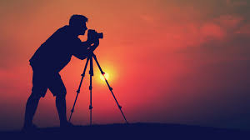

## 3. PHOTOGRAPHY IS A WONDERFUL STRESS RELIEVER

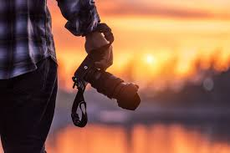I mean, really, how much can you concentrate on that all-consuming problem when you turn your focus instead to the petals of a flower, the wings of a butterfly, the graceful curves of a majestic mountain, or the dimples of a smiling baby? Go ahead. Take your blood pressure before and after spending just 30 minutes focusing on getting that perfect picture. You’ll be amazed at the difference. Then, for better overall health, just rinse and repeat often. It’s okay. I promise the problem won’t go away. It’ll still be there when you’re ready to start worrying again.

## 4. PHOTOGRAPHY INSPIRES YOUR IMAGINATION

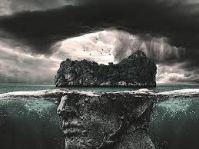My sister is a professional photographer and her creativity while taking photographs of the kids is what moved her (slowly) toward a career as a photographer. She loves finding and replicating such creative poses as a newborn in a net seemingly hanging from the sky. She also loves taking a couple and creating romantic ways for the shared love to be shown. It has inspired my own creativity, as I help her come up with new ideas. For instance, one day I was walking on a road with plenty of random cracks in it. The sun was behind me casting my shadow forward. We were talking on the phone about how to capture this one particular couple and the strength of their union and I mentioned the cracks all around them (symbolizing life in general). However, when it came to their shadows, they were solid. In this way it showed the strength of the union as well as how life couldn’t “crack” them

## 5. PHOTOGRAPHY AS A CAREER IS POSSIBLE FOR ANYONE WITH A TRUE PASSION FOR IT

There are people who make a living being a photographer. Imagine, if you will, that

every picture you’ve ever seen, whether it’s on a billboard, in a magazine, or on TV, was snapped by someone. There are schools, classes, books, and websites where you could learn much more than I could ever tell you. Remember, you have your whole life in front of you. Why not aim for a part-time career on the side?

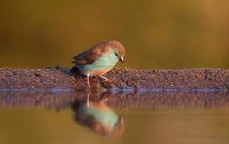

## 6. PHOTOGRAPHY IS A WONDERFUL, SAFE, AND NATURAL SELFESTEEM BOOSTER

My 14 year-old loves the feeling of pride she gets when she takes pictures of her friends

and they turn out good. When she downloads and sees them on the computer she’s in seventh heaven. And, of course, she loves sharing them with her friends.



## 7. PHOTOGRAPHY BRINGS YOU CLOSER TO YOUR NATURAL SPIRITUALITY

Look around at the wonders of nature. Whether you believe in God or not, you can’t help but feel a stirring at the beauty surrounding you. You simply can’t help but understand how very small you are while you are realizing how very vast everything else is.

## 8. PHOTOGRAPHY LETS YOU SEE THINGS THAT YOU MAY NEVER NOTICE OTHERWISE

When I look at something I can’t possibly take in every aspect that is within my vision. For instance, a beautiful sunset only lasts so long and I may not notice all aspects of how the colors play on the water (I live in a beach town). The look of the sand (such a simple thing) changes as the sun lowers. All of these aspects are much more evident in a picture, and I can concentrate on the overall view while knowing that the individual components will not be lost forever.

### 8.0 Skill developed / learning out of this Micro-project

1. Master your camera and shooting in manual

It seems like a basic concept but learning to use your camera is a fundamental first step to creating amazing images. Modern cameras can do so much but do you know what happens when you actually press each one of the many buttons? What is buried in that menu system? Can you create sharp photos in a variety of situations? Do you understand how your meter works? Can you shoot in manual and effectively use the exposure triangle? Get out your camera manual and read up. I know, I know, it’s boring. But I promise you it will be worth it. Read as much as you can and then practice, practice, practice. Use your camera every single day. The better you are at quickly and effectively using your camera, the better your images will be.

### 1 Use the Rule of Thirds

This rule helps you take eye-catching pictures by using one of the most effective rules of composition.

If you want to take pictures that have a “wow” factor built in them, the Rule of Thirds is the composition secret you need to take advantage of! To use the rule of thirds, imagine four lines, two lying horizontally across the image and two vertical creating nine even squares. Some images will look best with the focal point in the center square, but placing the subject off-center at one of the intersecting points of the imaginary lines will often create a more aesthetically composed photograph.

## 2 Avoid Camera Shake

Camera shake or blur is something that can plague any photographer and here are some ways to avoid it.

First, you need to learn how to hold your camera correctly; use both hands, one around the body and one around the lens and hold the camera close to your body for support.

Also, for handheld shooting, make sure that you are using a shutter speed that is appropriate for your lens’ focal length. If your shutter speed is too slow, any unintentional movement.**3**

### 3 Learn to use the Exposure Triangle

To get your photos looking their best, you need to master the three basics: Aperture, Shutter Speed and ISO.

You also need to understand the relationships between these three controls. When you adjust one of them, you would usually have to consider at least one of the others, to get the desired results.

Using Auto Mode takes care of these controls, but you pay the price of not getting your photos to look the way you wanted them, and often disappointing.

It’s a better idea to learn how to use Aperture-priority or Shutter-priority modes and ultimately shoot in Manual mode. To easily learn how to do it, we recommend

**9.0 Application of this Micro-project.**

Photography is a part of art that captures memories and lifetime events. Ever since time immemorial, artists have used pictures to describe a person’s emotions, mentality and physical state at a given moment. For many years now, we have learnt to store memories of our loved ones in photo albums. This idea has helped families carry on the memory of legends in their lives and show them to their kids and future generations. Technology has played an important role in photography.

Digital cameras, smartphones, tablets, i-pads, laptops and many more, have high tech cameras installed in them. All devices vary in the camera specifications but provide one with the capability to take photos and store them. Photography has become an essential activity in today’s era. Digital users can today, through different applications, tell a story through their photos and videos. Furthermore, these photos can be saved in the cloud and can also be retrieved anytime a user wants them.

Immortality

Believe it or not, photography affords immortality. If you look at pictures taken from the olden days, you cannot tell how they looked when they were older. A person does not grow younger or older in a photograph. Rather, they remain exactly the same way they looked when their photo was taken. With this, you can attain immortality in a picture and last for eternity despite in reality, being dead.

Documentation of your journey through life

Photography is the only means, apart from stories, where you can document your life’s journey from childhood to adulthood. Parents tend to keep memories of their children from their baby steps, to their smiles, school days, till they grow older. This is an activity that goes on from generation to generation. Through this, your life story is told in pictures and reminds you of the best and worst days you experienced.

Stress reliever

Photography does not have to entail your pictures only but also those of other living or dead things. When you are stressed or had a long day at work, you can take time and stare at the most beautiful pictures that can calm your soul. Beautiful pictures naturally tend to capture a person’s attention. One can take time to stare and appreciate a lovely picture of a butterfly, their pet, or the setting sun. A picture is worth a thousand words they say, so enjoy it while you can.

#### 10 Area of future improvement

Barriers to entry entail the challenges that owners face when establishing their businesses. If the difficulty is easy to overcome, then the market is identified as having a low barrier to entry.

Currently, the only significant barrier to entry for the photography market is considered to be the EU General Data Protection Regulations (GDPR), which came in to place in 2018. This regulation acts as a watchdog for how companies and individuals deal with personal data for their clients and therefore aims to guard people within the EU region from data malpractices. This act thus influences how photography is implemented, especially the aftermath of a photo or film session. Hence, through this act, photographers are supposed to have a robust data protection system to uphold the privacy, confidentiality, and the dignity of the data collected through taking of pictures or films. However, this only applies to those photos and or films which reveal personal data such as faces and also biometric information in the case of highresolution recordings in High Definition (HD) quality.

For UK residents, this entry barrier is likely to be scrapped upon realisation of Brexit. Therefore, should Brexit become successful, photographers in the UK will not be legally tied to invest in data protection systems. Instead, they will only do it as part of ethics rather than as a provision of the law. However, this will depend on whether the UK government will come up with another law which will legally bind photographers as a replacement of the GDPR.